SET 6 – PRODUCT SALES ANALYSIS
Aim
To analyze monthly product sales for the first quarter using a grouped bar chart, stacked area chart, and table in R.
Algorithm
- Create the product sales dataset for January, February, and March.
- Convert the data into a suitable format for visualization.
- Create a grouped bar chart to compare sales of each product.
- Create a stacked area chart to show the overall sales trend.
- Display the monthly sales data as a table.
- Add suitable labels and titles to all charts.
R Program
library(ggplot2)
library(tidyr)

sales <- data.frame(
Product = c("Product A", "Product B", "Product C"),
January = c(2000, 1500, 1200),
February = c(2200, 1800, 1400),
March = c(2400, 1600, 1100)
)

data_long <- pivot_longer(sales, -Product,
names_to="Month", values_to="Sales")

ggplot(data_long, aes(Month, Sales, fill=Product)) +
geom_bar(stat="identity", position="dodge") +
labs(title="Product Sales - First Quarter",
x="Month", y="Sales") +
theme_minimal()

ggplot(data_long, aes(Month, Sales, fill=Product, group=Product)) +
geom_area(position="stack") +
labs(title="Overall Sales Trend",
x="Month", y="Sales") +
theme_minimal()

print(sales)
output:
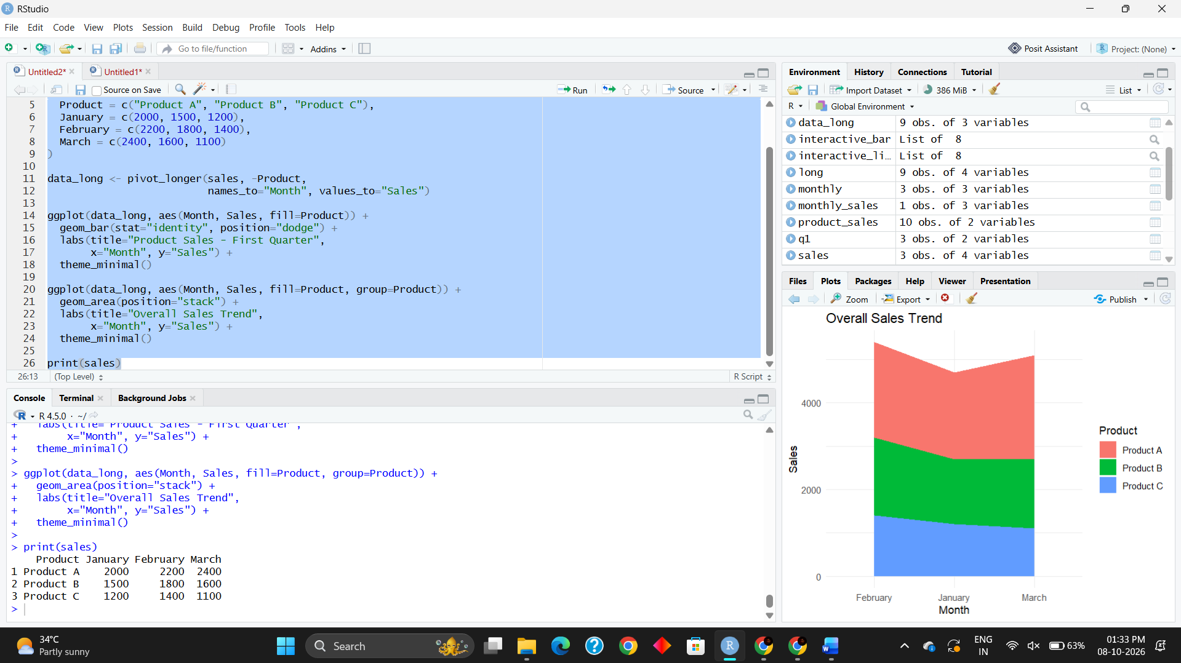
Result
The grouped bar chart successfully compares the sales of Products A, B, and C for January, February, and March. The stacked area chart shows the overall sales trend, and the table displays the monthly sales data for each product.

